Assignment 6
- Q1: Project Title & Abstract Submission
  - Title: Chemistry Synthesizer using Random Forests (RF) and Convolutional Neural Networks (CNN)
  - Abstract: Chemistry is the general study of the molecular interactions as well as a basic understanding of structural properties. Much of what we know today is comprised of laws and formula’s, all of which allow us to theoretically ascertain chemical properties prior to ever stepping into a lab.
This may take the form of synthesis reactions, as seen in organic chemistry and other courses, or through reaction diagrams and visualization of molecules.
As is the case with a variety of tools, merging the basics of chemistry with the advancements of machine learning will allow a new age of learning for the students, alongside a new assistant in the lab, allowing for faster computations and better experimentation. The proposed tool is a 2D workspace that understands the chemistry basics and can assess molecules and reactions, and perhaps even helping produce tips for better yields in lab even utilizing less expensive reagents.
The general structure of development will be broken down into three stages. The first phase will be to recognize and correctly identify chemicals using IUPAC convention. The second phase will consist of producing chemical properties based off the basic chemical principles. Thirdly, the model should culminate to performing synthesis reactions accurately, providing percent yields and alternate reaction pathways. The first stage is the primary result at the end of this course, so all other phases will be carried out concluding this semester. The proposed model will be built off of a RF for decision making, and a CNN for image processing.
  - Method (or Approach): Utilizing a CNN-based model, I will attempt to convert the images given to a SMILEs type notation. This notation is very machine-friendly, but does not do much for humans. As this is a standardized form, however, it is (mostly) possible to convert this to an IUPAC-convention name. This step, however, may use a random forest to generalize the important parts of the sequence and create rules on what names are assigned to what features in the SMILEs format.
- Q2: Algorithm & Flowchart
  - Algorithm:
    - As this is primarily a CNN, the general algorithm will pertain mainly to that.
    - Data Collection: As there is no datasets I could find that suited my needs, I have created my own dataset. This dataset consists of structural images in the form of PNG images, and the chemical’s associated qualities in the form of a JSON file. The dataset can be found at this site: https://huggingface.co/datasets/DarthJarJar/Chem_Structures_and_Info/tree/main
    - Data Pre-processing: As this is a large dataset, there is not much that can be done to every single image manually. Instead, we will need to make a pipeline. Doing such, there is a few major things to change. In essence, the features must be linked to the labels. All other image formatting steps can be skipped as all these images are of consistent size, even though the molecules vary in size. This is helpful that, though these images may be the same size, the fluidity in the actual molecule size gives the model more variety, leading to less bias. The linking between the feature (the image), and the label (the SMILES notation) must be done on the fly in the pipeline through the creation of a dataset. The dataset must generate the images as NumPy arrays, and the SMILES strings will stay consistent. This will allow the model to apply its kernels and produce what is needed.
    - The CNN: Utilizing a varying number of layers, the model will generate random kernels and analyze the images given. Upon assessment, it will make its own array. Depending on each layer and the sequence of layers (undefined as of now), the arrays will pool to get the max element or will just create more arrays. The resulting sequence of kernels will help the model determine what specific sequences of filters would be most helpful to analyze each image and correctly give the SMILES notation.
    - SMILES to IUPAC: This is currently an unsolved problem, though there is a variety of documentation on the web for possible solutions of converting machine-friendly SMILES notation to human-friendly IUPAC notation.
  - Flowchart
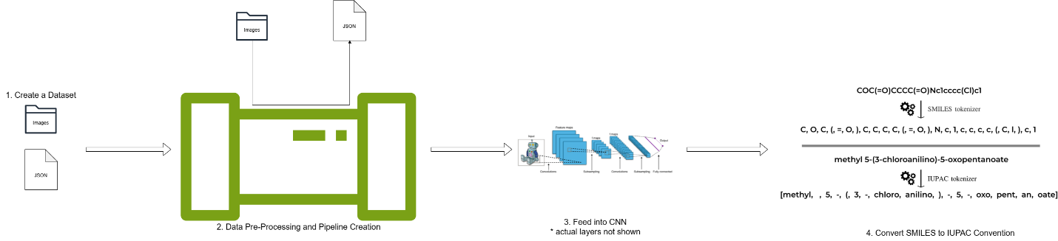
- Q3: Code Submission (40 lines at least)
  - The code is attached as a PDF file. This is a current version, which contains a variety of bugs. Nonetheless, this is a work in progress, so the code will only get better from here.

